CHBE 244 Notes
Christopher Kalitin - 25W2

Jan 7 (L2): Real Fluids - Equation of State Equilibrium

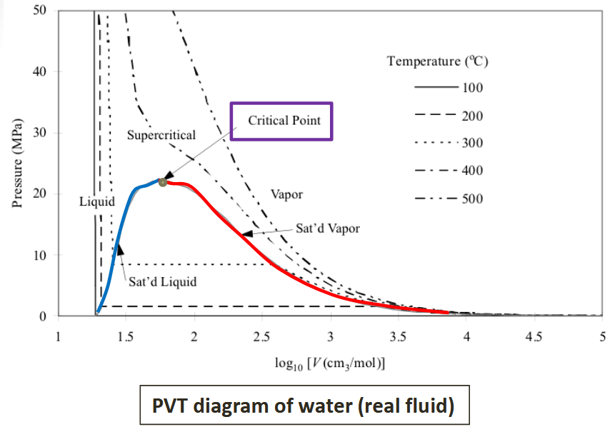

- PVT diagram, because those are the variables changing
- Blue curve is saturated liquid, bubbles start to form if you add heat - Bubble Line
- Red curve is saturated vapour, final liquid becomes gas - Dew Line
- Top right of critical point is a supercritical fluid
- Horizontal lines inside V+L region are a phase change from liquid to vapour, so constant temperature

q = quality = mass% of vapor
(while in V+L region, under curve)

Using q (sub in any given value for M, just interpolate):
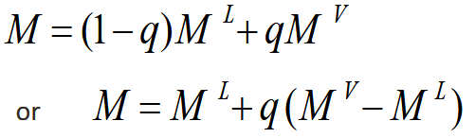

M^{L}, M^{V} (or any other property) found in steam table (print).

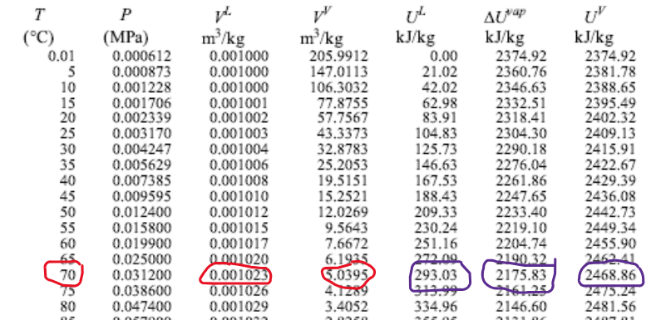

dU^{vap} is just U^{V} - U^{L}
Change in internal energy when you vaporize (latent process obv)

Jan 9 (L3): Interpolation

Saturated liquid = low enough pressure that bubbles start to form

If you drop the pressure of a liquid, at a certain point bubbles form. This is intuitive, imagine a vacuum.

“There’s a lot of beauty hidden between those lines”
Professor loves what you can discover from the tables too

See P_{sat} here:
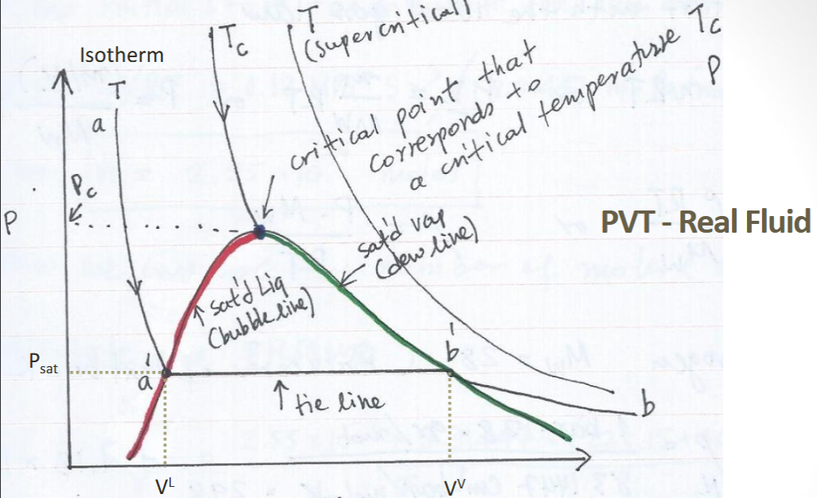

If given T, P of a fluid and you want to find the state, follow the algorithm:
- Find T on a steam table
- Find Psat for that T
- If P > Psat, liquid
- If P < Psat, vapour

Since Psat is a horizontal line, you can tell if you’re above or below it.

So much beauty in that diagram.

Jan 12 (L4): The Energy Balance, Conservation of Energy, First Law of Thermodynamics

The first law of thermodynamics is conservation of energy.

Change in temperature = sensible heat
Change in phase = latent heat

Molecules have two types of energy:
- Molecular kinetic energy (T)
- Molecular potential energy (forces)

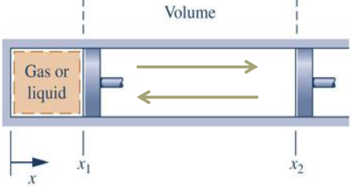

The force you apply to a piston is opposite the force the system experience, which is why we get the negative term.

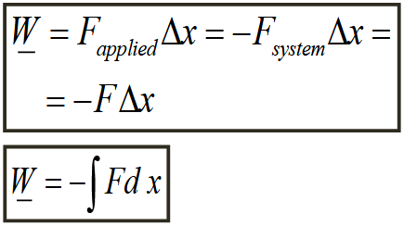

Increasing system energy = positive work (eg. contraction of volume = positive work)

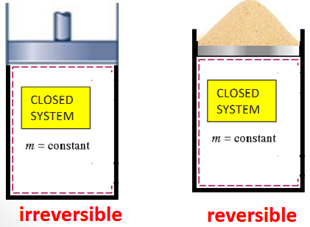

Fast compression leads to greater losses than slow compression.
Ie. pressing hard on a piston vs adding 1 grain of sand at a time. You get greater irreversible losses.
Irreversible losses:
- Friction
- Velocity and pressure gradients in viscous liquids
- Inelastic collisions

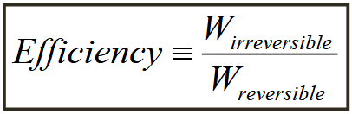

W_{irreversible} = work done for the irreversible version of a process

Shaft work is associated with centrifugal pumps or turbines.

Shaft work for no volume change:
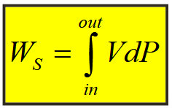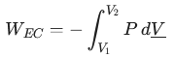

W_{EC} = expansion/contactraction work.

To find work associated with flow (knowing input and output parameters), we start with this formula:

Just variable manipulation until you get to W_dot = (PV)m_dot

Then:
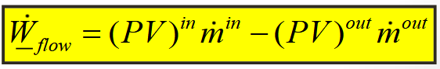

Heat directly changes internal energy:
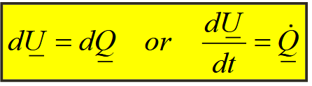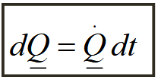

A system containing a boundary with no resistance to heat transfer but not allowing mass through is called a diathermal wall.

Important:
V = molar volume (intensive property)
V_bar = total volume (extensive property)

Computational tricks:
PV=nRT
P₁V₁ = P₂V₂ => P₁/P₂ = V₂/V₁
W = PdV

Work is not a state property!

Jan 14 (L5): The Energy Balance for Closed and Open Systems
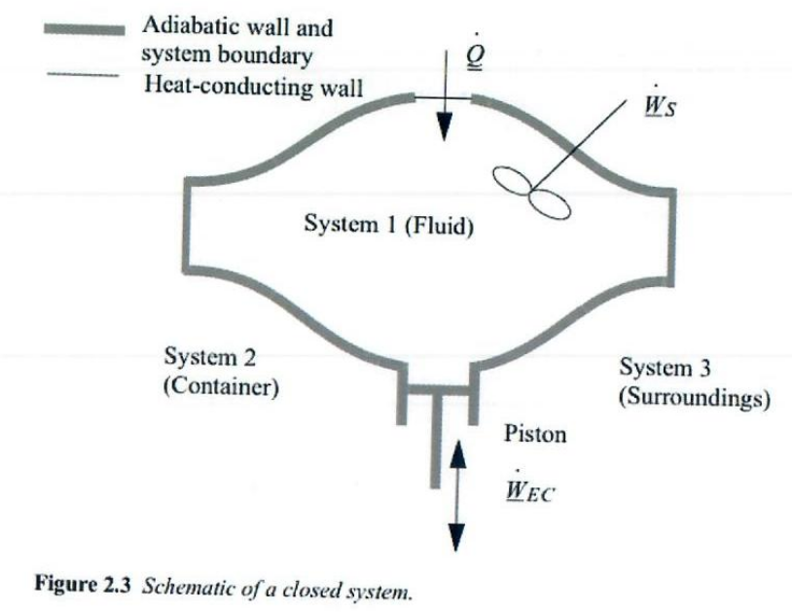
Note the difference between Adiabatic wall and heat conducting wall.

We omit kinetic and potential energy. So, dU = Q + W_{EC}

Thermodynamics is utilizing thermal energy to produce work.

Steady-state => time invariant

Closed System Balance:


Open System Steady-State Balance:
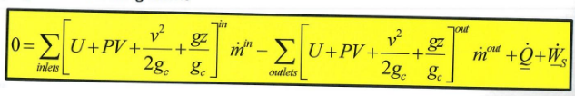

- PV is W_{flow}, work the flow of fluid is doing
- g_{c} = 1 in SI units, ~31 in imperial

Enthalpy:
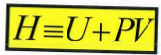
U represents internal energy
PV represents energy associated with the system’s physical presence in the environment (eg. pushing on walls).

Change in Enthalpy:
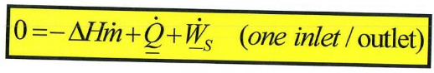

Divide by mass flow rate to get:
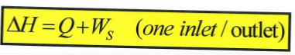

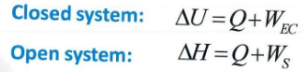
Note these are fundamentally different as U != H.
In a closed system, you can only change your internal energy, but in an open system you can change your interaction with the environment (PV) as well.

Enthalpy is a fundamental property. Gibb’s free energy and others are not fundamental, so are defined in terms of Enthalpy.

Pumps, turbines, and compressors operate at constant volume (change pressure), so their shaft work is:
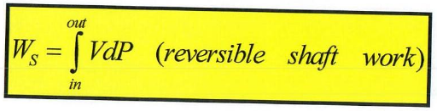
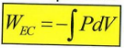
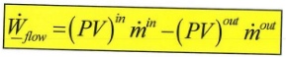

The integral of VdP is very hard, so we use ideal gas law to get:
For gas:
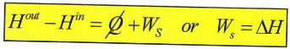
For liquid:
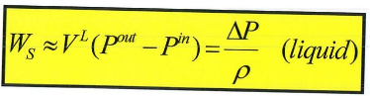

T_{R} = T/T_{C} = Reduced temperature
P_{R} = P/P_{C} = Reduced pressure

It’s with respect to critical temp/pressure.

Compressors pressurize gas
Pumps pressurize liquid

Positive Q_dot / heat = heat added

Jan 16+19 (L6+7): Internal Energy, Enthalpy and Heat capacities

Heat capacities provide a constant to relate temperature change to U, H change.

It’s a constant of proportionality.

For U and T, we use constant volume:
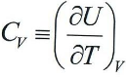

For H and T, we use constant pressure:
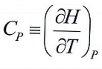

If we don’t have heat capacity, we can use this approximation:
PV=RT gives us (valid for ideal gasses):
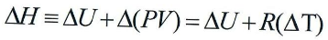

For liquids (with T_{r} < 0.75) and solids:
- Internal energy is weakly dependent on P for T_{r} < 0.75
- Molar volume is insensitive to pressure below T_{r} < 0.75
Hence:

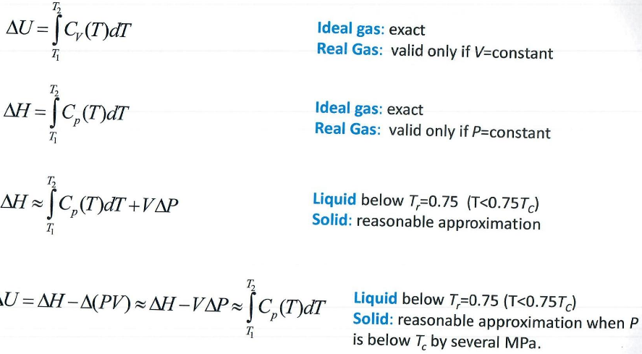

If you have dH^{vap}, but not dU^{vap}, you can relate them!

Take some time to understand that formula, but is PV minus? Why is P^{sat} there?

Just do practice problems to understand the formula

Jan 21 (L8): Energy Balances for Process Equipment

Throttling Valves

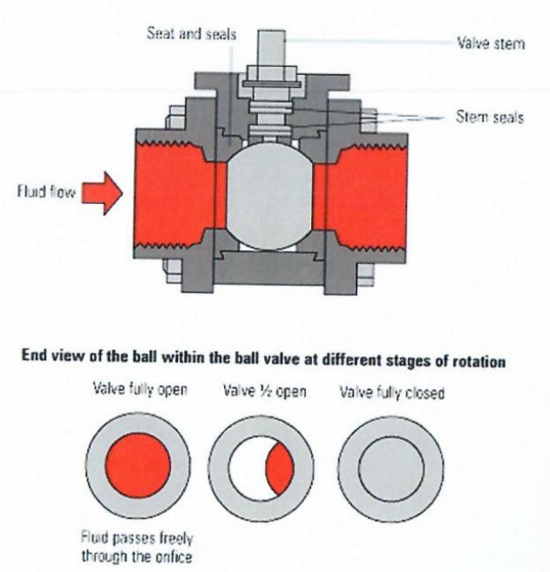

Throttling values:
- Change pressure
- Isenthalpic (dH = 0)
- Since H = U + PV
- Since P decreases, V must increase (specific volume)
- Since V changes, velocity changes as well (but negligible)

Nozzles
Convert enthalpy to velocity
Enthalpy = H = U + PV, we’re mostly working with the PV term presumably, internal energy is not changing.
Notice the energy balance, we have enthalpy and velocity terms.
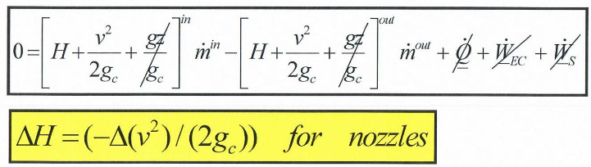

Heat Exchangers

Tube-in-shell heat exchanger:
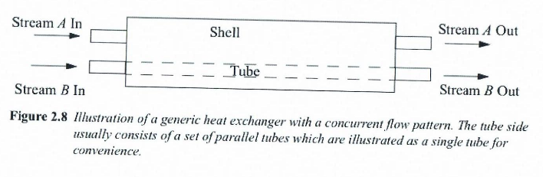

Energy balance on stream B, assuming it’s being boiled (for sign):
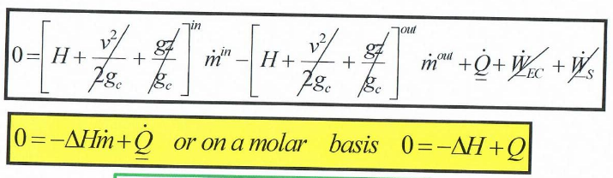

Note that the energy balance on the whole system has Q_dot = 0, only the enthalpy of both streams changes:
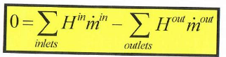

Adiabatic Turbines

Convert kinetic energy to shaft work.

Note adiabatic = no heat transfer externally. These would be losses.

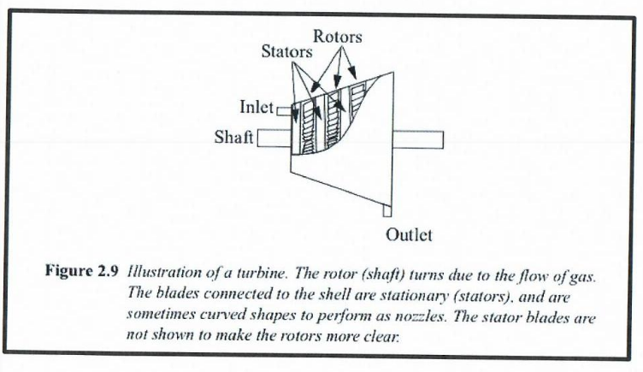
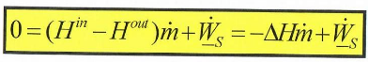

All adiabatic steady-state turbines, compressors, pumps:
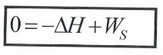

You can very easily calculate enthalpy change with the equation above, if you have shaft work:
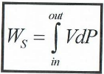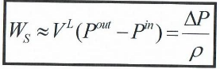

Jan 21 (L9): Practice Problems

Jan 26 (L10): Energy Balances for Composite Systems Heat Engines and Heat Pumps The Carnot Cycle

https://gemini.google.com/share/2067a54dbac1

Shaft work output is negative by convention:
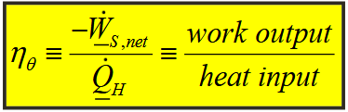

Step a: Isothermal heat is added. Expansion work is what this added thermal energy goes into. Ie. Q = W_{ec}

Why does volume change like that? Why does the transition from isothermic to adiabatic occur?
- At point b, the hot reservoir is no longer connected. Instead of heat expanding the volume, internal energy now starts expanding the volume (PV).

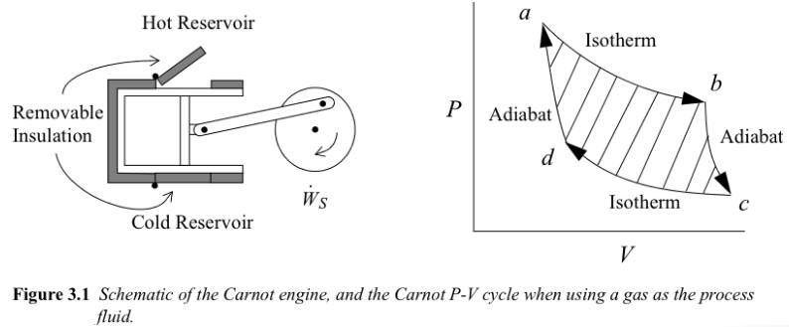

Net energy balance:
-W_{EC} = Q_{H} + Q_{C}

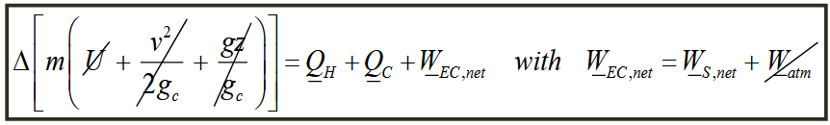

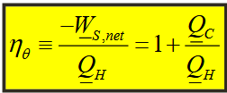

Why doesn’t Q_{C} show up in the first part of the efficiency equation?
- Q_{C} is negative, so it’s heat leaving the system (which is why we 1 + Q_{C}/Q_{H})
- -W_{S} is our useful work output (what we normalize for) and Q_{H} is heat input.
- So, we get work useful to us over heat input (Q_{C} is wasted energy).

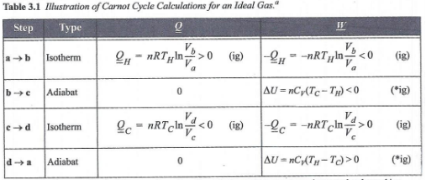

Need to remember the Q and W equations for different types of processes! Just do a project that involves this, or practice questions.

Because both adiabatic steps take place at constant temperature (T_{H} and T_{C}), their temperature changes are equal and opposite, so their work is equal and opposite.

Also, this implies the volume ratio for each Adiabatic step is equal:

Hence, we get:
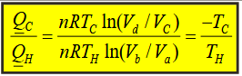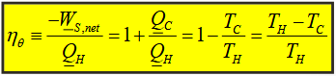

I’ll need to understand the meaning of all terms in these formulas.

The Carnot Heat Pump is running every step in reverse. Heat is absorbed from the cold reservoir and rejected into the hot reservoir.

COP = Coefficient of performance (for heat pumps)
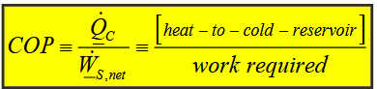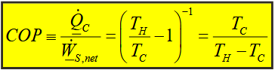

COP = T_{C}/(T_{H}-T_{C}) looks like 1/x for T_{H} as the independent variable. We see asymptotically decreasing performance for greater difference between T_{C} and T_{H}.

Because T_{C} is on top, a greater T_{C} means the graph stretches vertically, making efficiency of a constant dT greater. T_{H} = T_{C} + dT

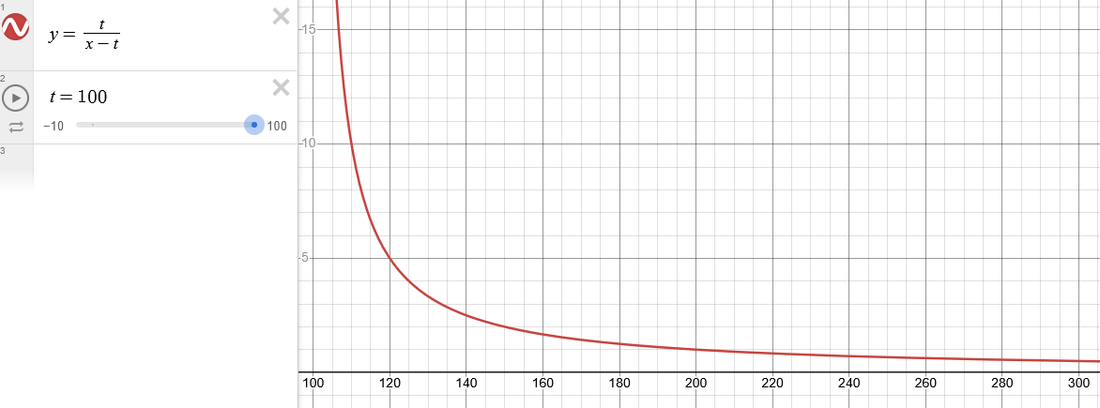

First law of thermodynamics:

Note that we add W, which means it’s usually negative for power cycles. This is the classes sign convention.

